​​ ​ ​ សាកលវិទ្យាល័យភូមិន្ទភ្នំពេញ

ROYAL UNIVERSITY OF PHNOM PENH

​​ ​ មហាវិទ្យាល័យវិស្វកម្ម

FACULTY OF ENGINEERING

ក្រុមទី​៣

១.គួច សុខឡាយ

២.ភឹម ភ័ក​

​​​​ LIST OF COMPONENTS

1.ESP 32 Module

* ESP32 is **a series of low-cost, low-power system on a chip-microcontrollers with integrated Wi-Fi and dual-mode Bluetooth**

.

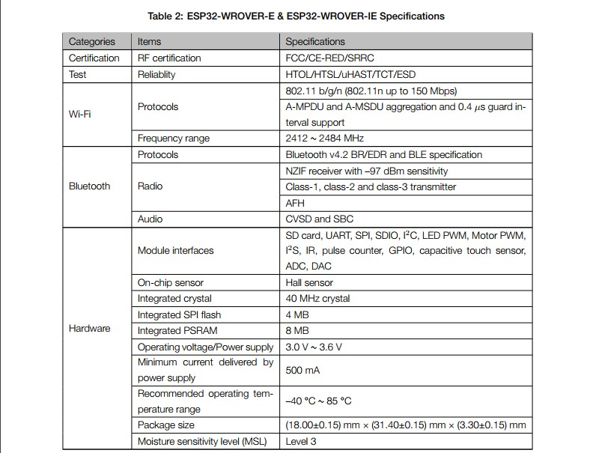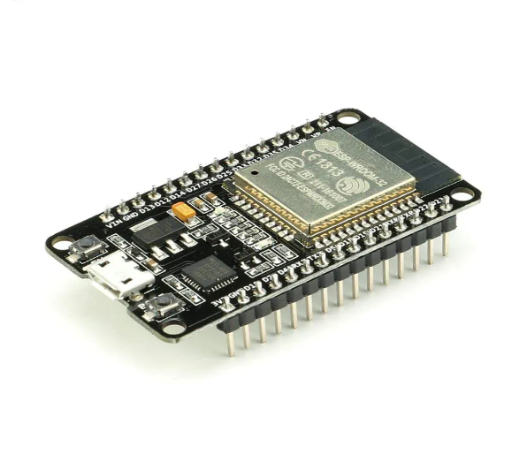

2. Fingerprint sensor

* A Fingerprint sensor is a type of technology that identifies and authenticates the fingerprint of an individual in order to grant or deny access to a computer system or a physical facility

The specifications of the Fingerprint sensor

* 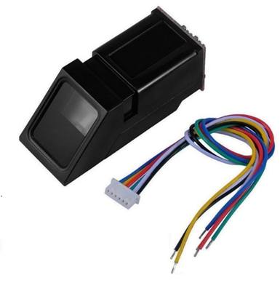The fingerprint sensor is an optical type
* The speed of scanning is 0.5sec
* The speed of verification is 0.3sec
* Supply voltage: DC 4.2V-6 V
* Working current 50mA
* Fingerprint image input time:<0.3second
* Window area:14*18mm
* Characteristic file size:256 bytes
* Template size: 512 bytes

3.OLED Display

* OLED (**Organic Light Emitting Diode**) displays provide darker darks, brighter colors, as well as higher contrast ratios and viewing angles

The specification of OLED Display:

* 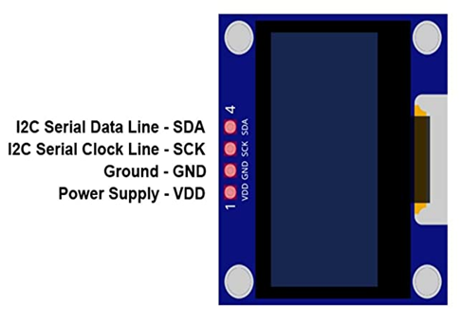Resolution:128*64
* IC:SH1106
* Interface Type: SPI/I2C
* Display Color: Blue or White (Optional)
* Operating Voltage:3.3 – 5.0V
* Logic Voltage:3.3V
* Operating Current: 20ma
* Operating Temperature:

-40~70°C

* Dimensions:35.4*33.5mm
* Weight:5.7g

4. Buzzer

* An electrical device that makes a buzzer noise and is used for signal

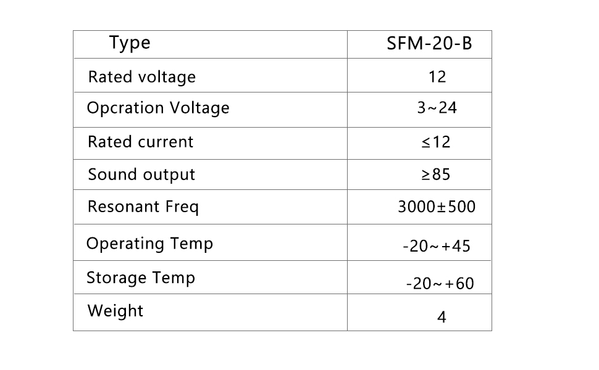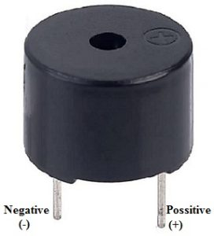

5. SD Card

SD Card Module is **a breakout board used for SD card processes such as reading and writing with a microcontroller**

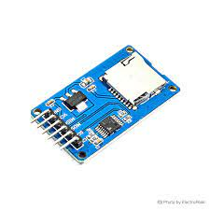

**Specifications:**  
Power supply voltage VCC: 4.5 - 5.5  
Electric current: 0.2 - 200 mA  
Interface level: 3.3 or 5 V  
Support Card Type: Micro SD card (<= 2G), Micro SDHC cards (<= 32G)  
Size: 42X24X12 mm  
Weight: 5g